|  |  |
| --- | --- |
| **Team ID** | **PNT2022TMID20252** |
| **Project Name** | **IoT Based Smart Crop Protection System For Agriculture** |

IBM WATSON IOT PLATFORM

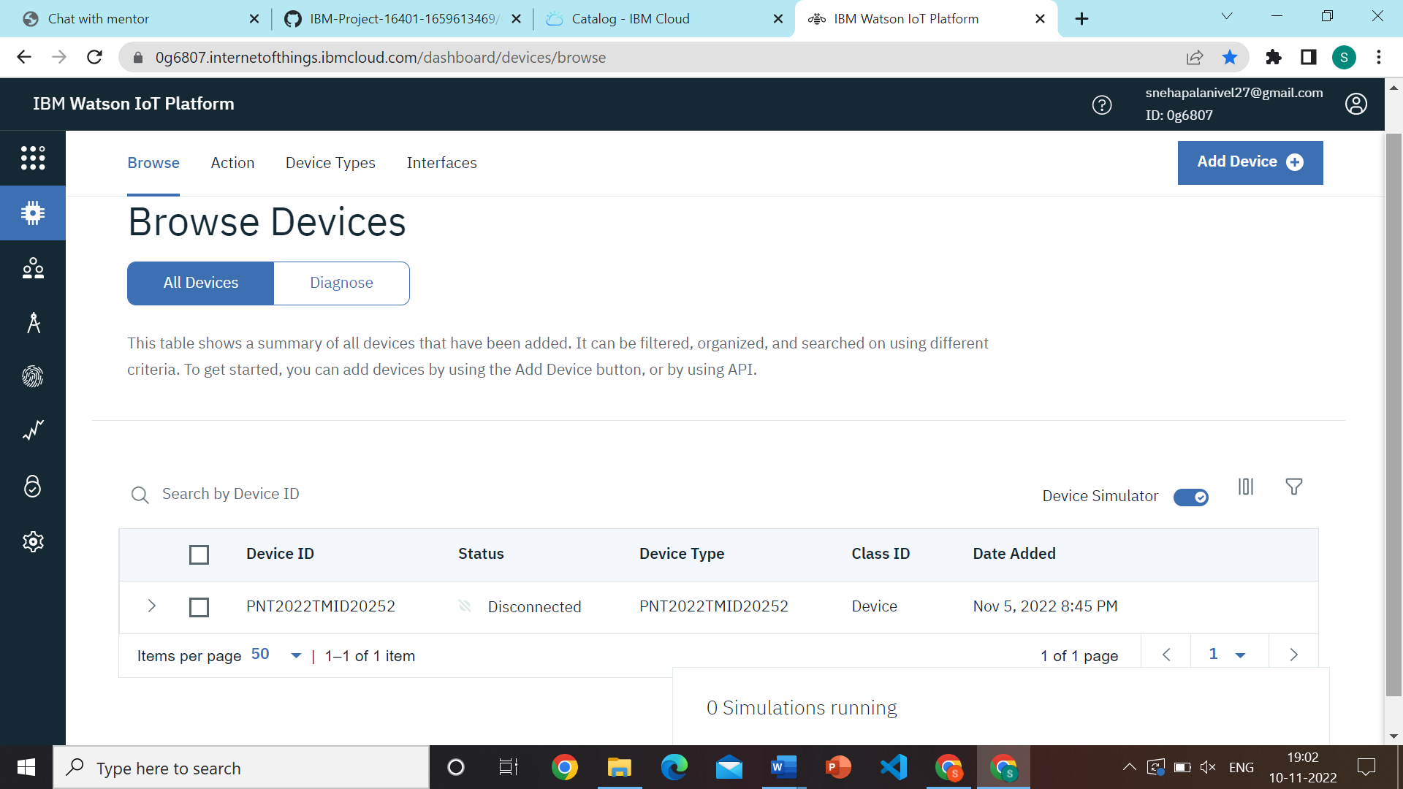

NODE RED

